Case 1

1.Open binomial module in your web application

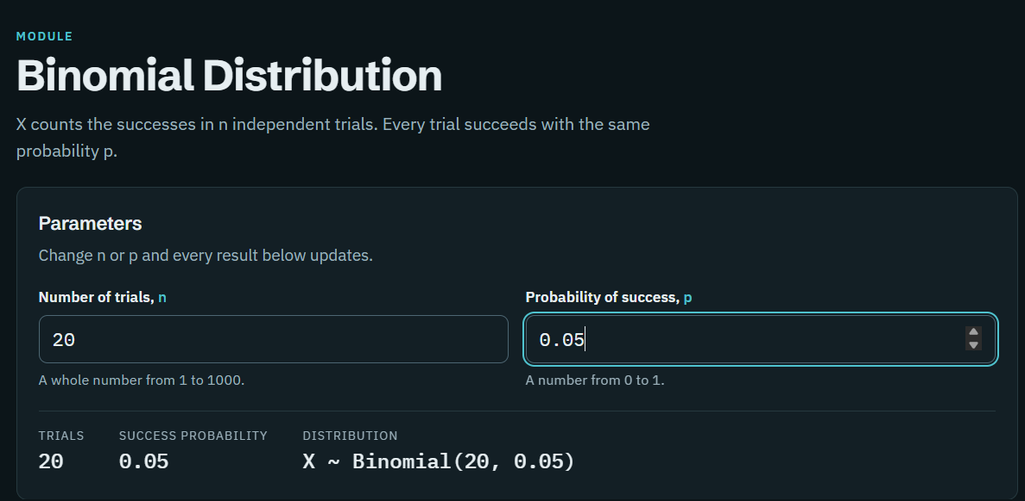
2. Enter n=20 and p=0.05
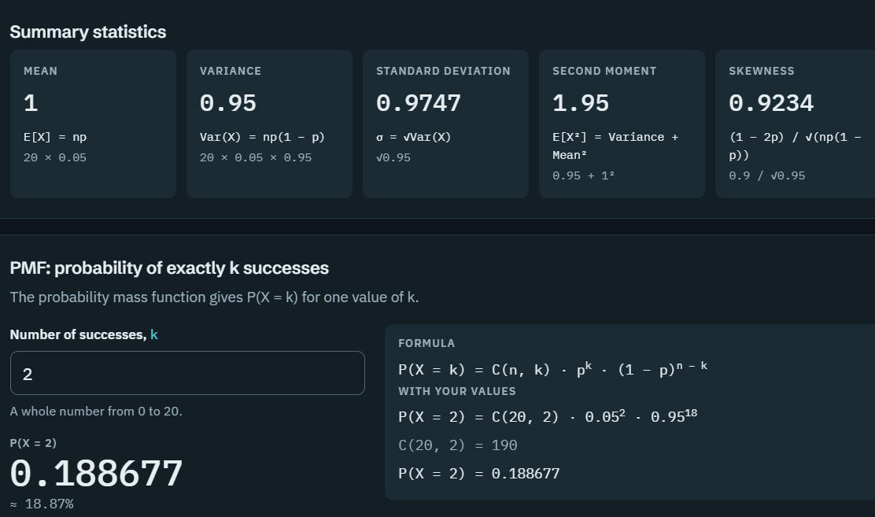
3. Calculate the mean , variance , probability of exactly 2 defects.
4.View the PMF graph. The horizontal axis represents the number of defects and the vertical axis represents the probability of each count.
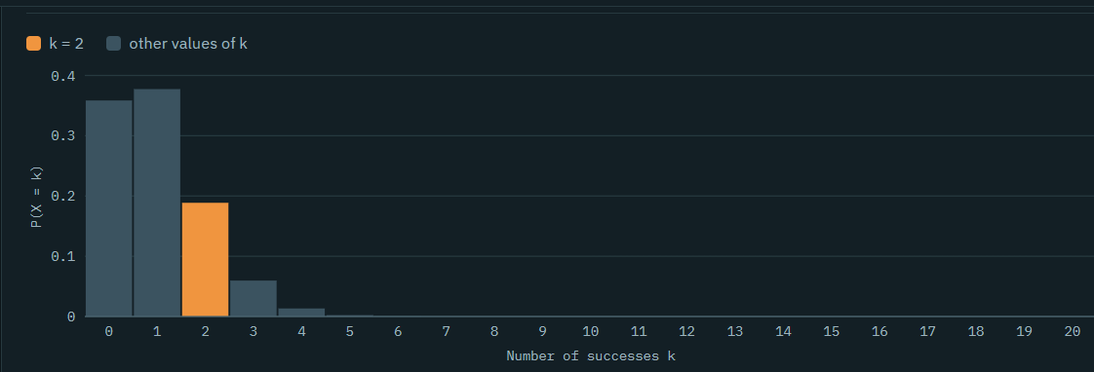
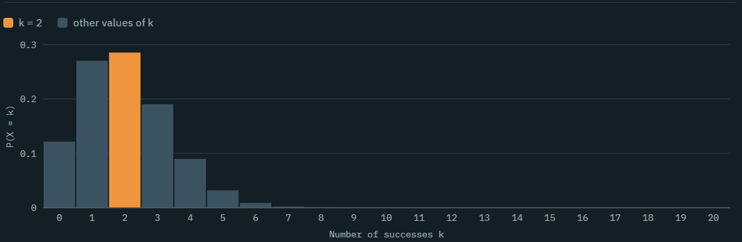
5. Change the defect probability from 0.05to 0.10. Observe how the distribution shifts toward larger defect counts.

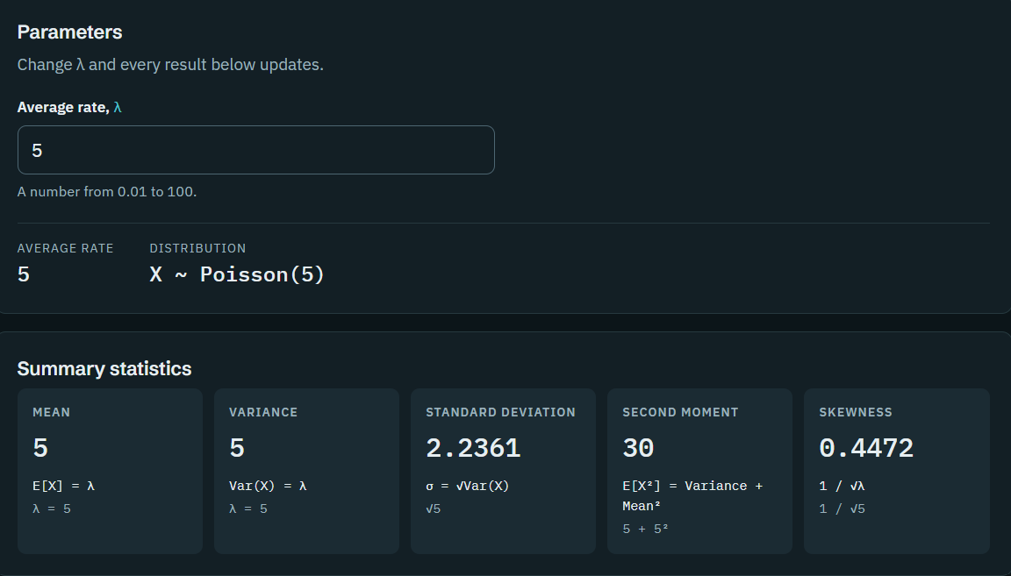
6. Open the Poisson module and enter lambda = 5 for 100 inspected products. Co7. Open the Geometric module and enter \(p = 0.05\).
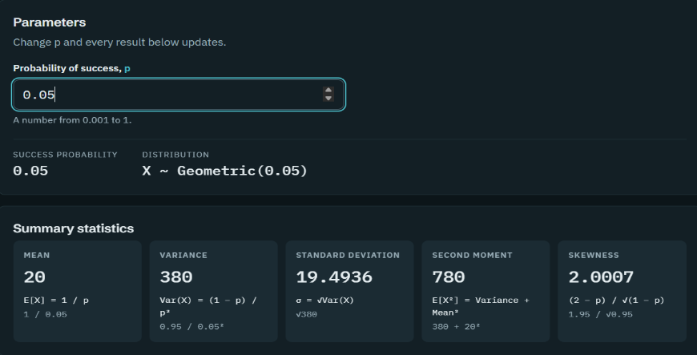
7. Open the Geometric module and enter p = 0.05. Examine the probability of detecting the first defect on different inspection attempts.
8. Write down the numerical results, graph observations, and an inference about the quality-control process.
Numerical Results
>>Binomial Distribution (n = 20, p = 0.05)
- Mean = 1
- Variance = 0.95
- Standard deviation = 0.9747
- Probability of exactly 2 defects: P(X=2)=0.188677, approximately 18.87%.
When the defect probability increases to p=0.10
- Mean = 2
- Variance = 1.8
>>Poisson Distribution lambda = 5
- Mean = 5
- Variance = 5
- Standard deviation = 2.2361
- Second moment = 30
- Skewness = 0.4472
>>Geometric Distribution p = 0.05
- Mean = 20
- Variance = 380
- Standard deviation = 19.4936
- Second moment = 780
- Skewness = 2.0007
Graph Observations
- Binomial: The graph shows that 1 or 2 defects are more likely than larger defect counts when p=0.05.
- Increased defect probability: When p increases from 0.05 to 0.10, the distribution shifts toward larger defect counts.
- Poisson: The distribution is centered around 5 events, with probabilities decreasing for larger counts.
- Geometric: The probability of detecting the first defect decreases as the number of inspection attempts increases

Inference
- The results show that when the defect probability is low, most products are expected to have few or no defects. Increasing the defect probability increases the expected number of defective products. The Poisson distribution helps estimate defect counts, while the Geometric distribution estimates how many inspections may be needed to detect the first defect.

Case 2
1. Enter the data: Use the monitoring table to identify the failure rate and average alert count.
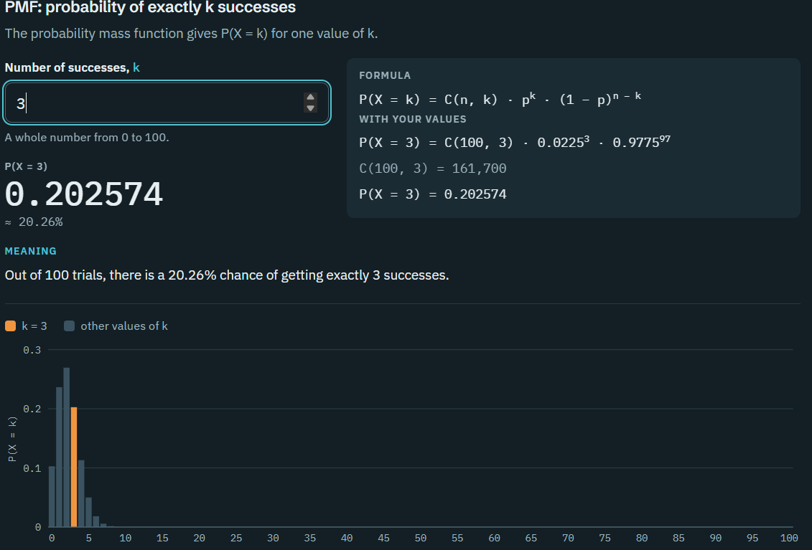
2. Select Binomial: Set n = 100 and p = 0.0225. Calculate the probability of exactly 3 failures and view the PMF.
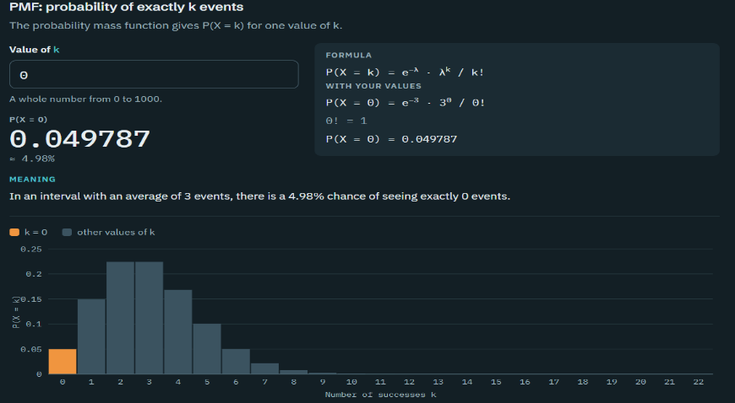
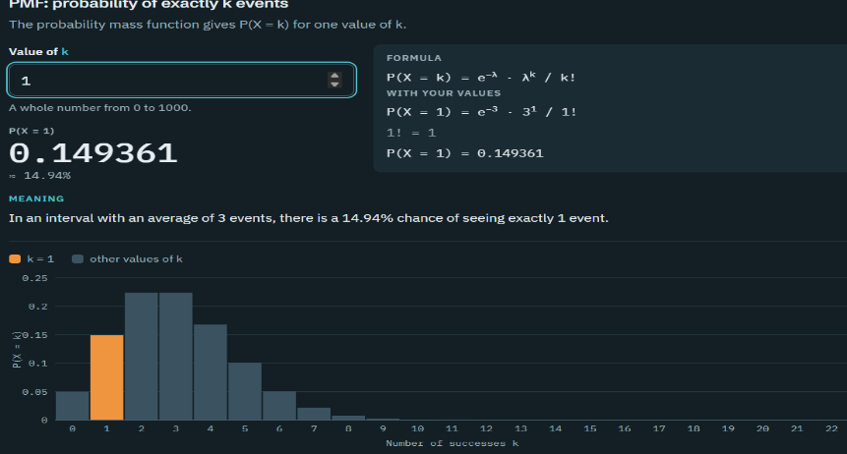
3. Select Poisson: Set lambda = 3. Calculate the probabilities of 0, 1, 2, 3, and higher alert counts. View the graph.
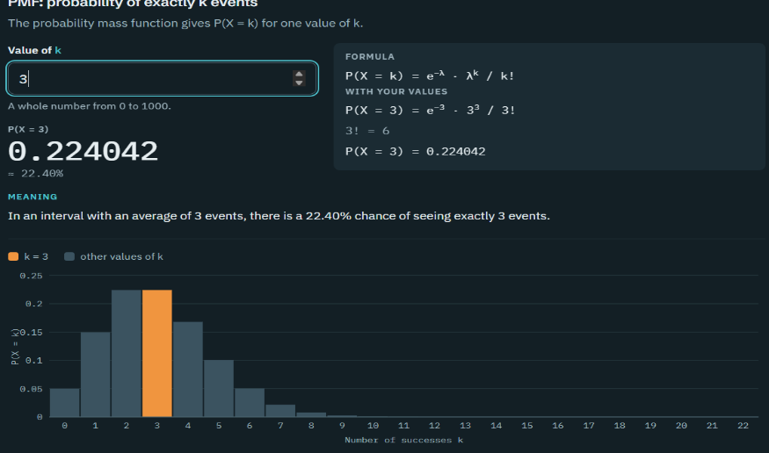
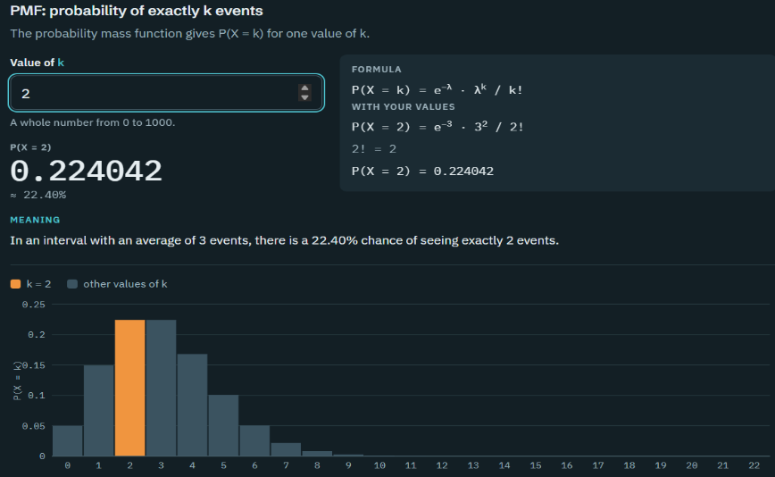
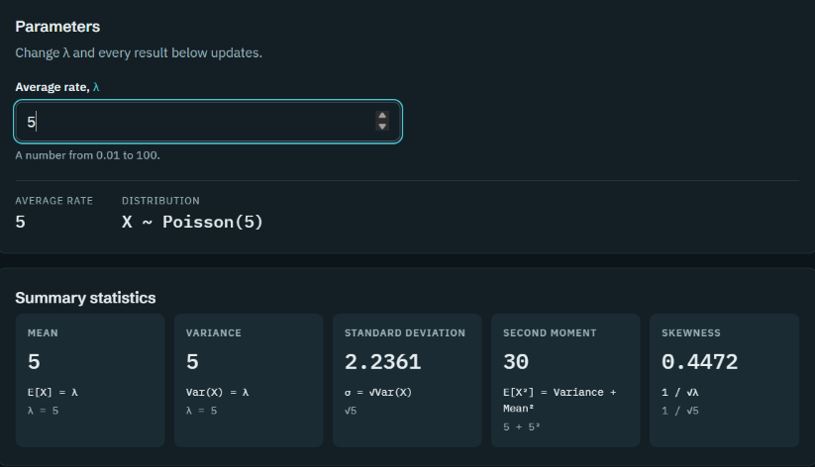
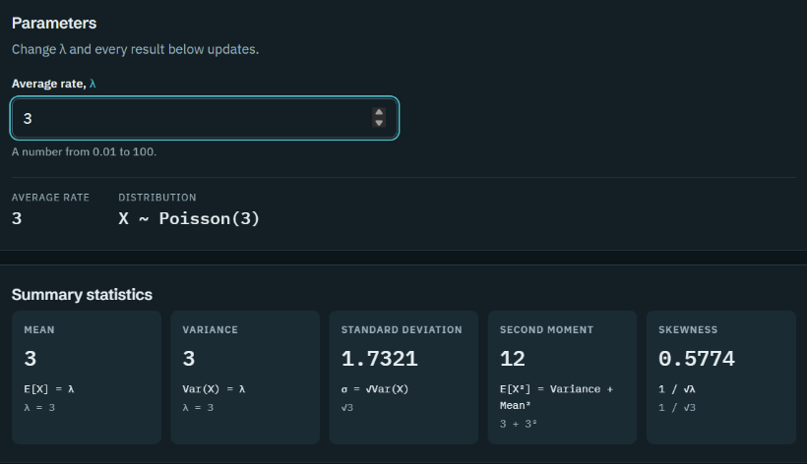
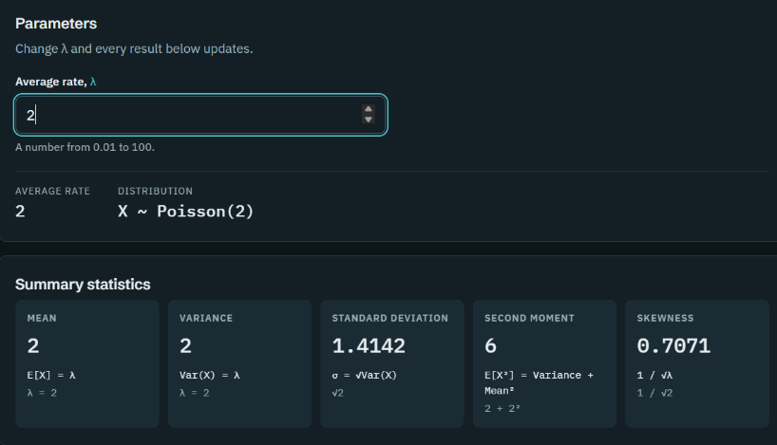
4. Experiment with lambda: Compare lambda = 2, lambda = 3, and lambda = 5. Observe how the distribution shifts as the average alert count increases.

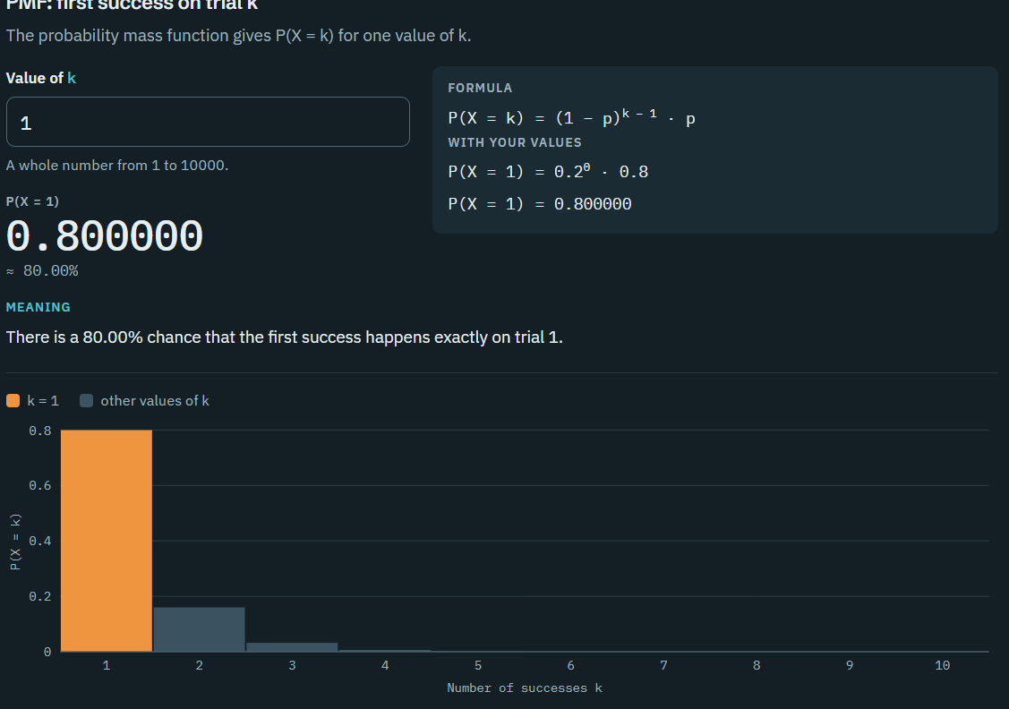
5. Select Geometric: Set = 0.8. Calculate the probability of success on the first, second, and third attempts.

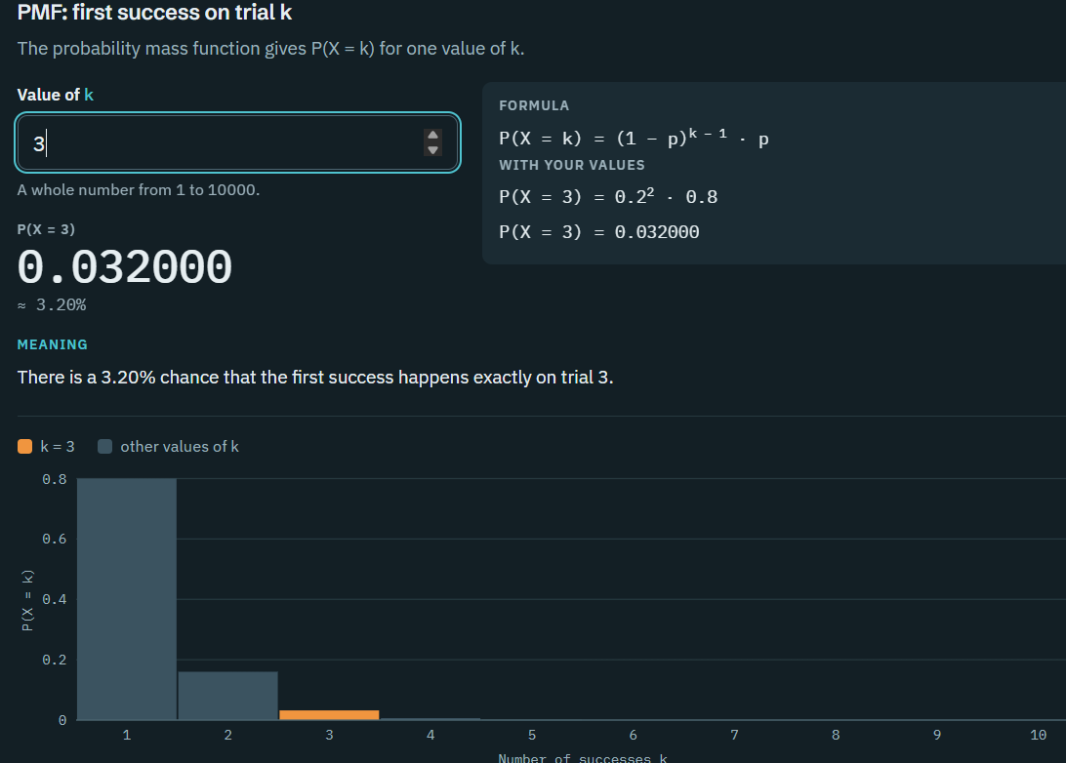
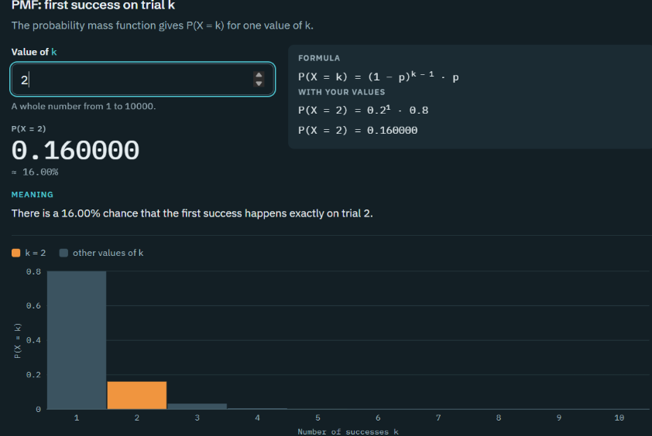

6. Interpret the results: Discuss whether the calculated probabilities could help the operations team plan monitoring thresholds, investigate failures, or evaluate retry policies
Based on the calculated probabilities from the SDAV Lab web application, the results can help the operations team improve system monitoring, investigate failures, and evaluate retry policies.
1. Binomial Distribution: The probability of exactly 3 failures in 100 trials is 20.26%, with a failure rate of 2.25%. This helps the team understand expected failures and identify unusual failure patterns.

2. Poisson Distribution: With an average of 3 alerts, the probabilities are:
Number of alerts (k) | Probability
0 | 4.98%
1 | 14.94%
2 | 22.40%
3 | 22.40%
These probabilities help the team establish monitoring thresholds and investigate unusually high alert counts. Increasing λ from 2 to 5 indicates a higher expected number of alerts.
3. Geometric Distribution: With a success probability of 0.8, the chances of success on the first, second, and third attempts are 80%, 16%, and 3.2%, respectively. This helps the team evaluate retry policies and decide how many attempts should be allowed.

